3rd Grade Daily Learning Opportunities
Tuesday, May 5, 2020

As always, please use parental supervision when accessing the internet.
30 minutes  Reading | Rhyming Scheme Lesson  Complete this Seesaw activity  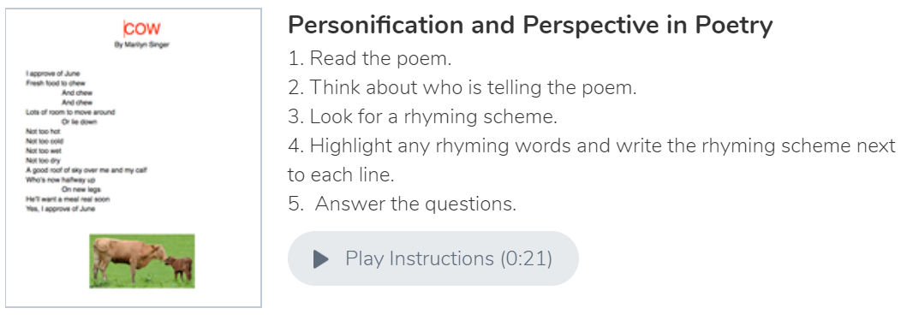
30 Minutes  Writing/Grammar | Watch the BrainPOP Jr. video about poems  BrainPop Jr. Topic: Poems  Watch Mrs. Campbell’s video below  Poetry Day 2  Complete the Acrostic Poem Organizer below and turn it into your Seesaw or Office 365
30 Minutes  Math | Telling Time Lesson 2  Watch the video below to review time to the hour, half hour and quarter hour  Lesson 2 Time  Optional: Make a clock with Mrs. Paliskis  Make a clock( optional)  BrainPopJr - Time to the half and quarter hour  Seesaw Follow up on Time 12 problems  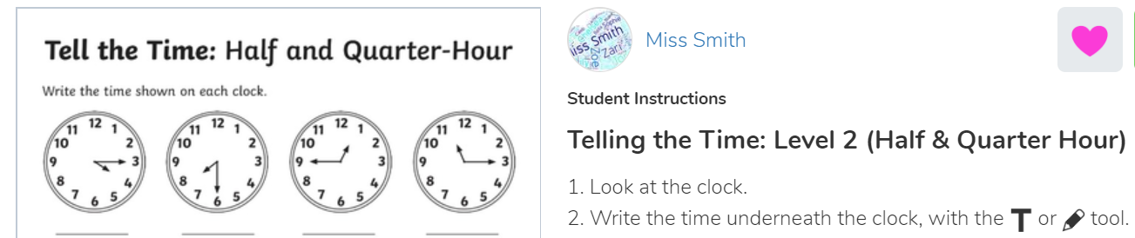
30 minutes  Social Studies/Science | British Colonization  Video & Vocabulary  - Watch the video to increase your knowledge of the 13 colonies!  13 American Colonies  - Complete the matching vocabulary activity below and check your answers with the key. (Show off your work by sharing with your teacher!)
Extra Time? Try this! | Make a Colonial American TOY: Whirligig!  https://www.mountclare.org/education/MakeYourOwnWhirligigToy_PlayLearn.pdf  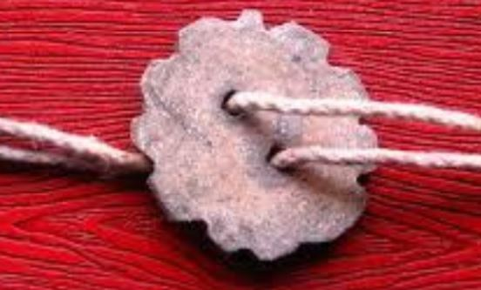
Don’t forget about these resources too! | Education Galaxy, RAZ Kids, Prodigy, typing.com, cursive practice, and multiplication.com

13 Colonies ~ Vocabulary
Directions: Match the vocabulary word with the definition. Send a picture to your teacher!

____ New World a. the careful use of $, goods & services

____ New England Colonies b. A territory that is settled & ruled by country

____ Middle Colonies c. resources found in nature
____ Southern Colonies d. Connecticut., Mass., Rhode Island, New Hampshire

____ Economy e. People who make goods, sell goods or provide services.

____ Human Resources f. Maryland, Virginia, North Carolina, South Carolina, Georgia

____ Capital Resources g. English colonies that were founded in the 1600’s to 1700’s.

____ Natural Resources h. The name that Europeans call the Americas.

____ Colony i. The resources or “tools” that people use to create goods and complete services.

____ 13 Colonies j. Pennsylvania, New York, New Jersey, and Deleware

