3rd Grade Daily Learning Opportunities
Monday, May 4, 2020

As always, please use parental supervision when accessing the internet.
30 minutes  Reading | Poetry Stanzas and Lines Lesson  1. Click the link above to watch the video lesson.  2. Complete the Stanzas and Lines page at the bottom of this lesson plan. 3. Take a picture and submit it to your teacher.  Here are some poetry websites you can use if you’d like:  https://www.poetry4kids.com/  https://www.dltk-kids.com/type/poetry.htm
30 Minutes  Writing/Grammar | Click on the link below to watch a video with Mrs. Campbell  Poetry Unit- Day 1
30 Minutes  Math | Daily Fact Practice  - Complete the Math Multiplication Review A at bottom of this lesson plan.  - Take a picture and send to your teacher!  Introduction to Time with Mrs. Paliskis – Click on link below.  - Telling Time Lesson 1  - Scavenger Hunt through your house - How many analog and digital clocks can you locate in your home?  Seesaw –Go to seesaw for this assignment!  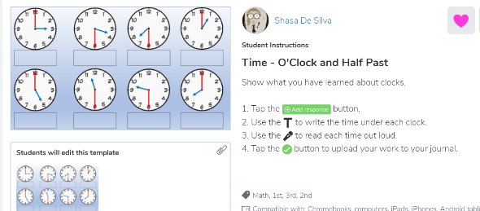
30 minutes  Social Studies/Science | Social Studies: British Colonization Unit  (What? When? Where?)  - View video below:  Introduction with Mrs. Saleeby  - Complete the Seesaw Activity  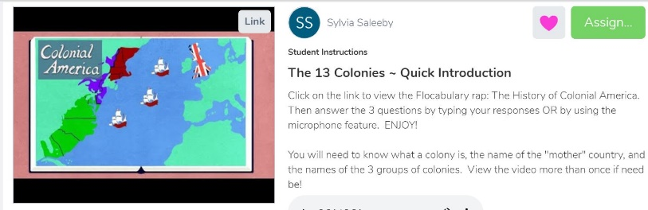
Extra Time? Try this! | Try these Star Wars activities today!  Build an X-Wing Star Fighter  Build a Recycled Droid  Yoda Shape Craft  Lego Star Wars Games
Don’t forget about these resources too! | Education Galaxy, RAZ Kids, Prodigy, typing.com, cursive practice, and multiplication.com

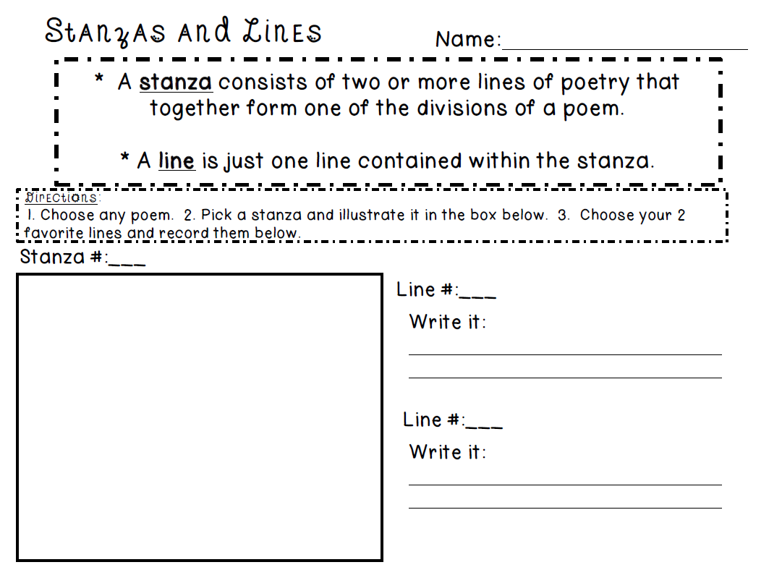

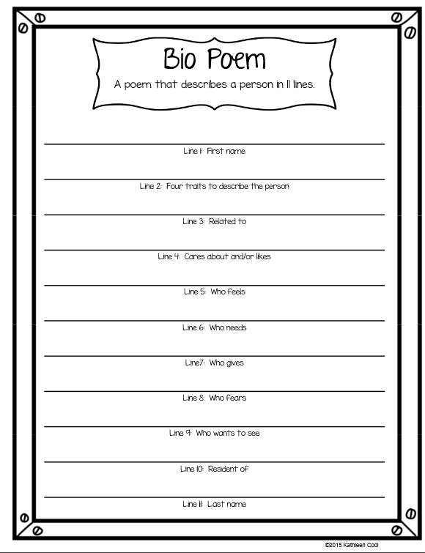

Math Review Sheet A

