3rd Grade Daily Learning Opportunities
Wednesday, May 6, 2020

As always, please use parental supervision when accessing the internet.
30 minutes  Reading | Use these poems to answer the questions attached to the bottom of this lesson plan.  We’re Running Out of Toilet Paper  I’m Keeping My Distance
30 Minutes  Writing/Grammar | Re-watch the BrainPOP Jr. Video by clicking the link below (if needed):  BrainPop Jr. Video Topic: Poems  Watch the video with Mrs. Campbell  Poetry Day 3  Choose to complete the graphic organizer below or use a blank piece of paper to create a concrete poem.  *Use Seesaw or Office 365 to share your work.
30 Minutes  Math | Daily Fact practice Review!  Answer the math facts attached to the bottom of this lesson plan! Mixed B Practice page!  Brainpop Jr –Telling Time to the minute lesson  https://jr.brainpop.com/math/time/timetotheminute/  Telling time activity at the bottom of this lesson plan! Scroll down to view  5 questions & a daily schedule to create!
30 minutes  Social Studies/Science | British Colonization  (Why? & How?)  - Watch the video:  MEET JAMES EDWARD SMITH  - It’s a BRAIN POP kind of day!  https://www.brainpop.com/socialstudies/ushistory/regionsofthethirteencolonies/  (Watch and take the quiz today. Don’t worry if you don’t do well. This one is hard, but give it a try!)
Extra Time? Try this! | 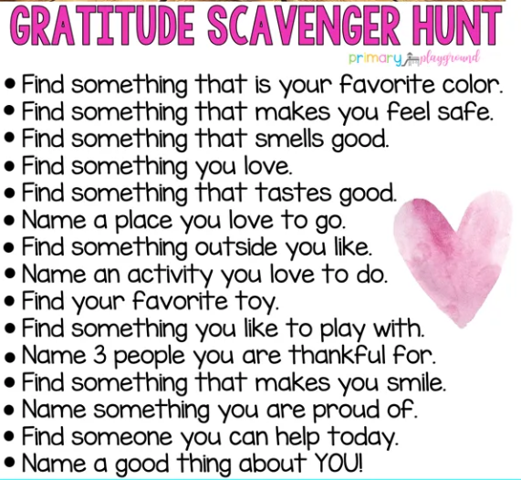  Click here for a larger version
Don’t forget about these resources too! | Education Galaxy, RAZ Kids, Prodigy, typing.com, cursive practice, and multiplication.com

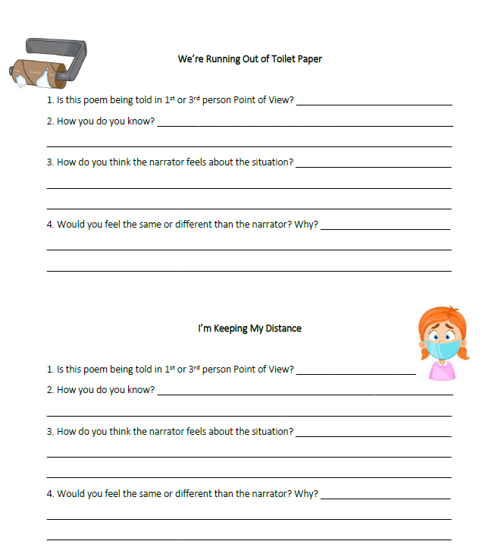

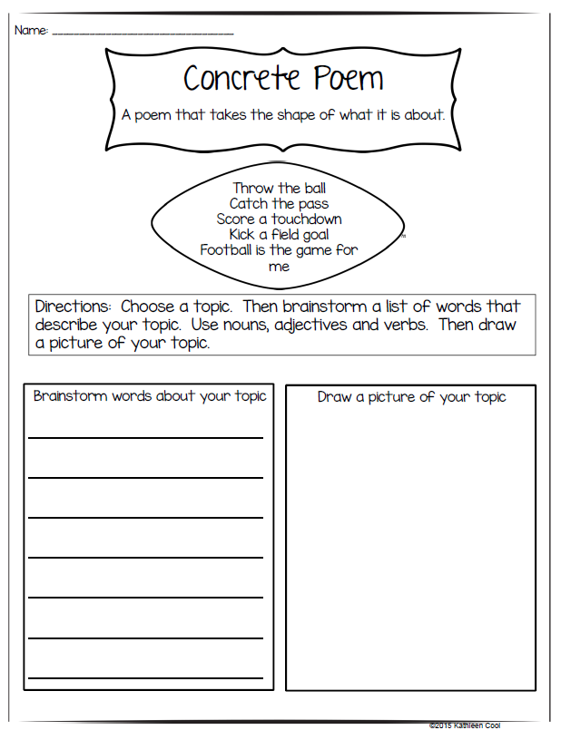

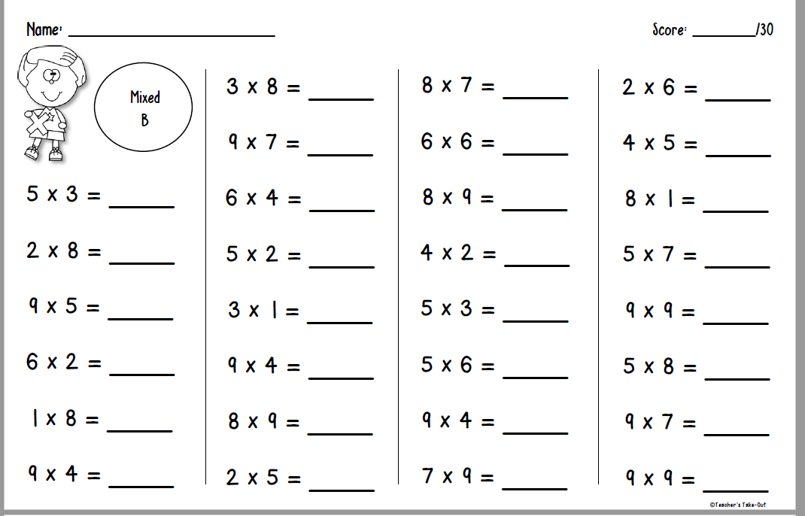

Telling Time Review Activity

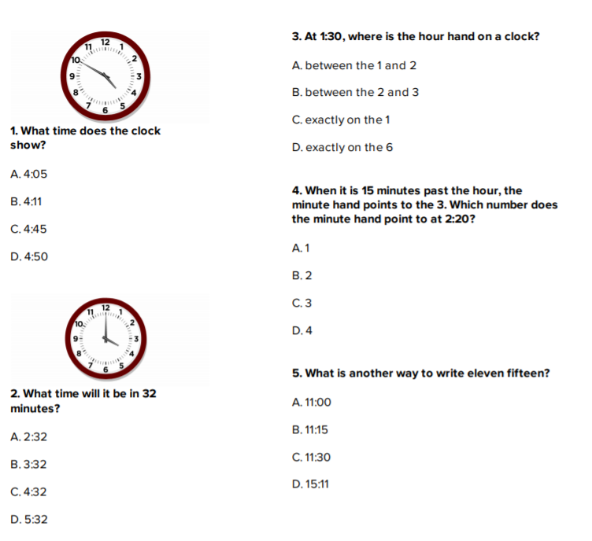6. Make a schedule of your day with 4 to 6 important times and activities you do at that time.
- Draw a clock for each time.
- Draw the hour and minute hand to represent the time.
- Write the time down
- Write the activity you are doing at that time
- Bonus – draw a picture to match! - See an example on next page
Example of a possible day!
7:00 I am waking up!
9:30 I am at my computer working on my math.

12:10: Hmmmm – what could I be doing now!

Have fun with this! Be creative! Send to your teacher when done by taking a picture and uploading onto Office 365 or Seesaw!!!!

