3rd Grade Daily Learning Opportunities
Thursday, April 30, 2020

As always, please use parental supervision when accessing the internet.
30 minutes  Reading | Cactus Directed Drawing  Complete the directed drawing then read about the different types of cacti (at the bottom of this lesson plan). Tell a parent what type of cactus you think you drew.
30 Minutes  Writing/Grammar | Funny Bunny & Patches Review Video  Complete the Compound Sentence review sheet at the bottom of this lesson plan. Don’t forget to add a comma after your conjunction word. Use your FANBOYS fan to help you.  (Take a picture and turn it in on Seesaw or type your answers in Office365 and submit that way)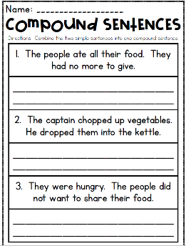
30 Minutes  Math | 1. Watch the video below to review all facts 0-12 with music!  https://safeYouTube.net/w/mNF8  2. Complete the Seesaw activity  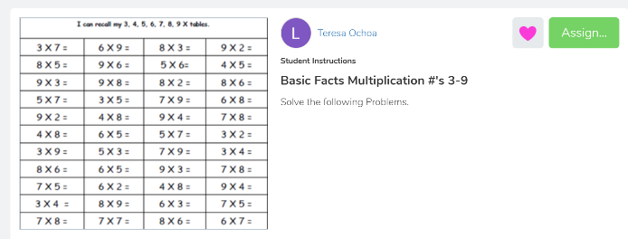  3. Complete the Secret Message review sheet at the bottom of this lesson plan. Take a picture once complete with the secret message and turn in on Seesaw.
30 minutes  Social Studies/Science | Watch the review video on HEAT!  Science for Kids: Heat Energy  Complete the quiz at the bottom  the daily plans.
Extra Time? Try this! | 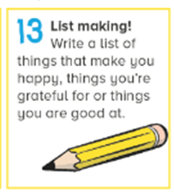
Don’t forget about these resources too! | Education Galaxy, RAZ Kids, Prodigy, typing.com, cursive practice, and multiplication.com

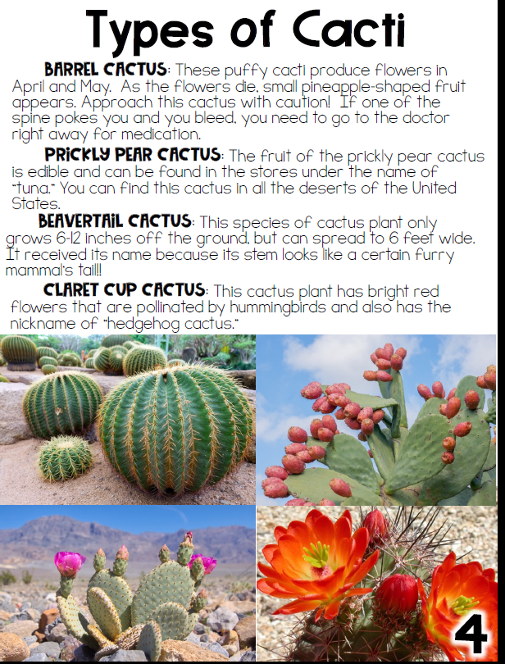

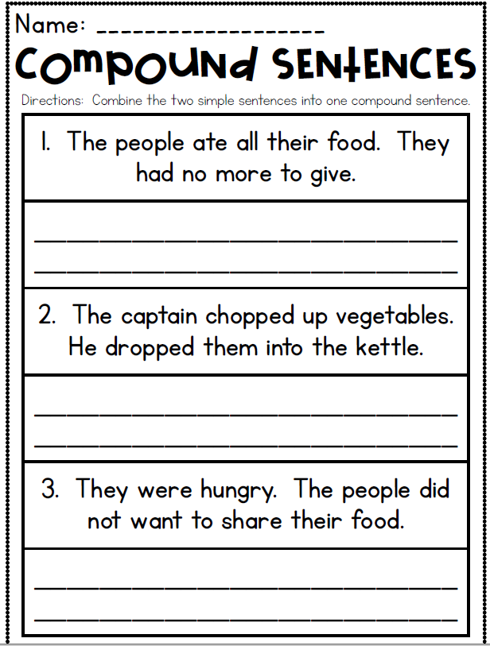

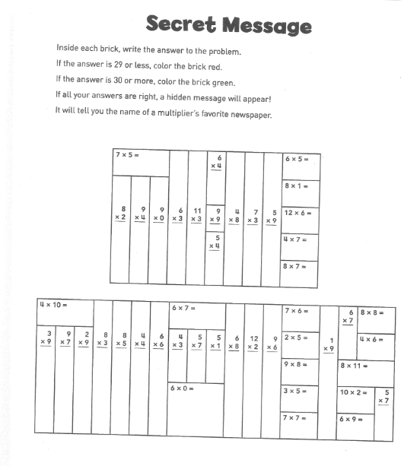

HEAT QUIZ
Complete the quiz and send to your teacher. You may take a picture and upload it to Seesaw or complete the questions and send through Office 365.

- What is temperature?
- What happens when something melts
- A measure of how hot or cold something is
- The ability to make something get warmer
- A kind of energy when something is hot

- What is an example of friction?
- Putting ice cream in the sun makes it melt
- Placing water in the freezer
- Wearing dark clothing causes someone to sweat
- Rubbing two hands together produces heat

- What happens when an object absorbs heat?
- The object takes in heat.
- The object blocks heat.
- The object bounces heat back.
- The object produces heat.

- Harold’s mother takes some bread out of the oven. Why does she put on oven mitts?
- Her hands will look better.
- Her hands are cold.
- She wants to keep clean.
- She wants to protect her hands from the heat.

- . Which word means to bounce off?
- Absorb
- Interact
- Reflect
- Block

- Jamal is toasting marshmallows on a stick over a campfire. In what direction does heat flow to toast his marshmallows?
- From the air to the fire
- From the fire to the marshmallows
- From the marshmallows to the logs
- From the stick to the marshmallows

- Jason wants to use a material that will absorb the most amount of sunlight. Which material should he use?
- Clear plastic wrap
- Black fabric
- Aluminum foil
- White paper

- Mali sets a bowl of hot soup on a table. Which statement best describes what happens when she puts the spoon in the soup?
- The air’s temperature will decrease.
- The soup’s temperature will increase.
- The bowl’s temperature will increase.
- The spoon’s temperature will increase.

- Judy put a slice of hot pizza on her plate. When she picks up the plate, it feels warm. In which direction did the heat flow?
- From the pizza to the plate
- From her hand to the plate
- From the plate to the pizza
- From her hand to the pizza

