3rd Grade Daily Learning Opportunities
Tuesday, May 12, 2020

As always, please use parental supervision when accessing the internet.
30 minutes  Reading | First, watch these two videos.  Compare and Contrast Flocabulary Video  Compare and Contrast Dory and Marlin Video  Then, read both polar bear passages at the bottom of this lesson plan and fill out the Venn Diagram comparing and contrasting the two passages. Try to come up with about 5 facts for each section of the Venn Diagram (about 15 total). Take a picture and turn it in to your teacher.
30 Minutes  Writing/Grammar | First, watch the video.  How To Be a Third Grader Introduction  Then, complete your introduction in your Office 365 account. Don’t forget to save. If you have difficulties with Office 365, you may also write it on a sheet of notebook paper. We will be working on this all week.
30 Minutes  Math | Elapsed Time  First, complete Seesaw Elapsed Time Activity  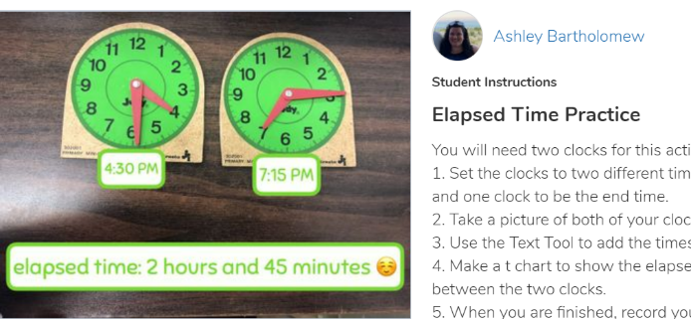  Print and cut out the clocks at the bottom of this lesson plan to help you with the Seesaw activity.  **If you can’t print, just draw two clocks on a sheet of paper**  Then, play this Elapsed Time game
30 minutes  Social Studies/Science | Social Studies: 13 Colonies  - Click on video below:  Middle Colonies with Mrs. Saleeby  - Watch the Brain Pop, Jr. Video!  https://jr.brainpop.com/socialstudies/americanhistory/thirteencolonies/  - Complete the following:  Pop a Joke, Belly Up, Game  & Complete the Easy Quiz!  (Want a challenge? Try the Hard Quiz.)
Extra Time? Try this! | Guess the children’s book emojis.  Ex. The first one is “Green Eggs and Ham”  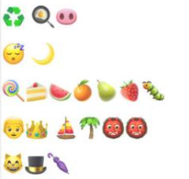
Don’t forget about these resources too! | Education Galaxy, RAZ Kids, Prodigy, typing.com, cursive practice, and multiplication.com

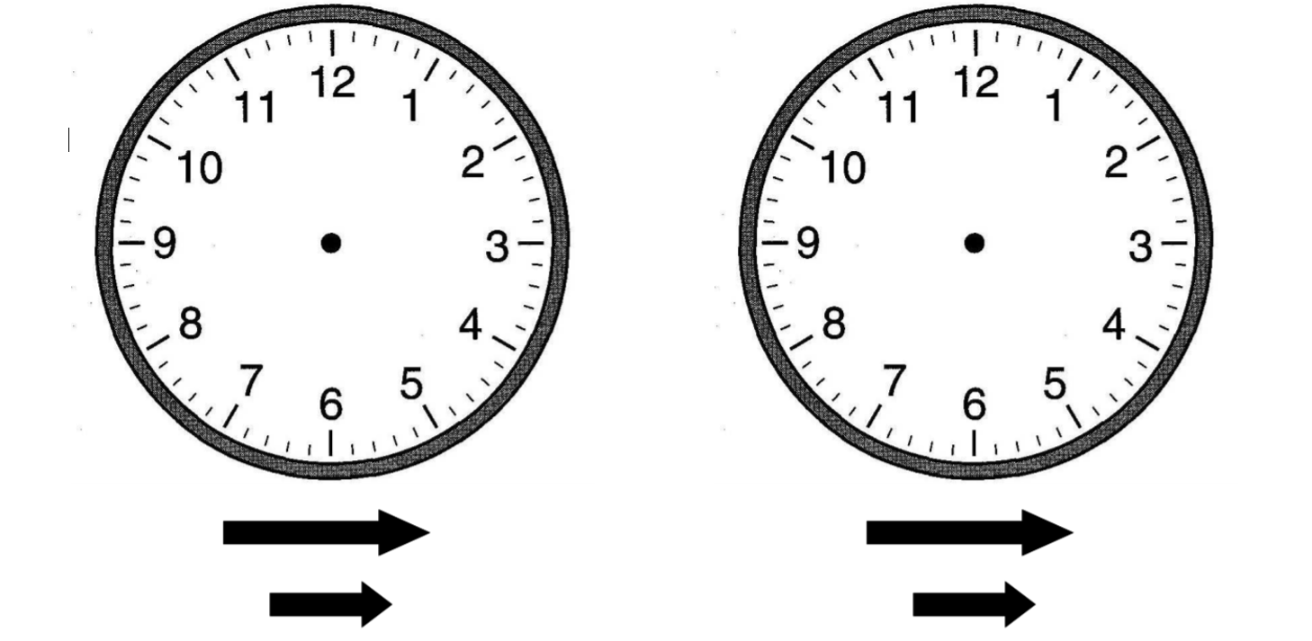

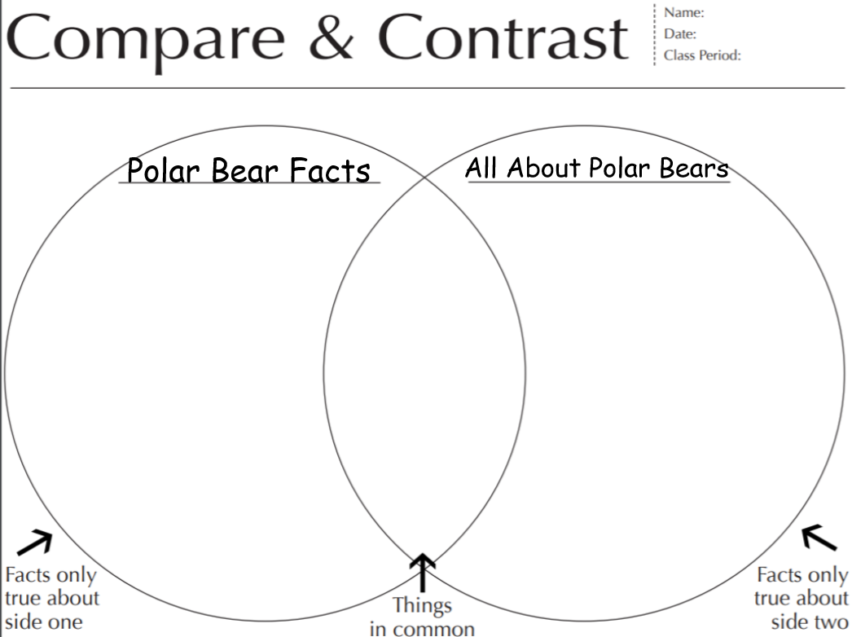
The passages are similar because _________________________________________________
____________________________________________________________________________________
_____________________________________________________________________________________

The passages are different because ________________________________________________
_____________________________________________________________________________________
_____________________________________________________________________________________

