**3rd Grade Daily Learning Opportunities  
Last week of 3rd Grade**

**May 18-20, 2020**

**Complete the memory book a little bit each day on Monday, Tuesday, and Wednesday!**

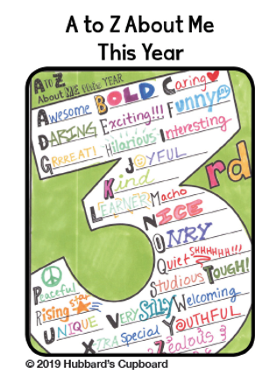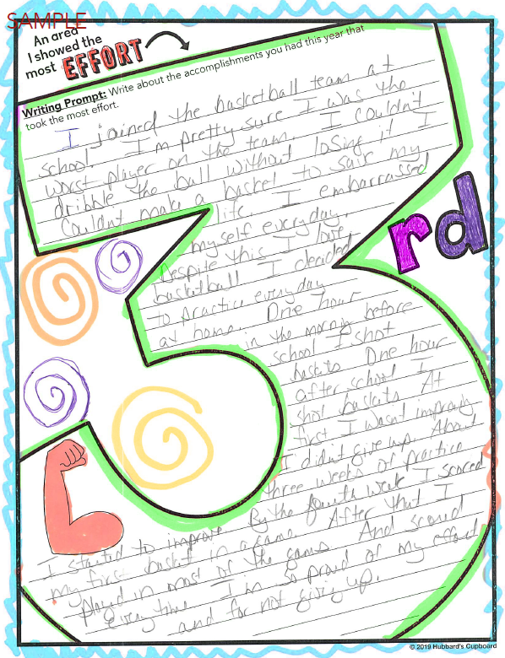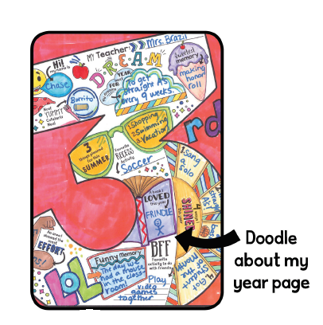

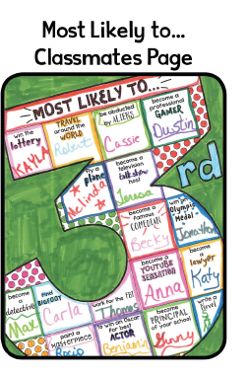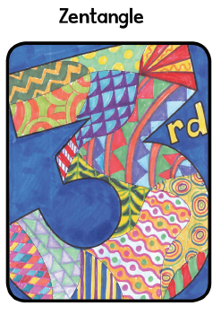

**😊 When you finish, staple it or tie it together (like a book) with ribbon. Keep this 3rd grade memory book as a keepsake to look back on someday.**

**You DO NOT need to turn this book in to your teacher.**

**It’s for your fun and enjoyment. Have fun and be creative!!!**

